JAIN UNIVERSITY

# NAME: ALOK SINGH

# USN: 22BTRAD020

## RANGE

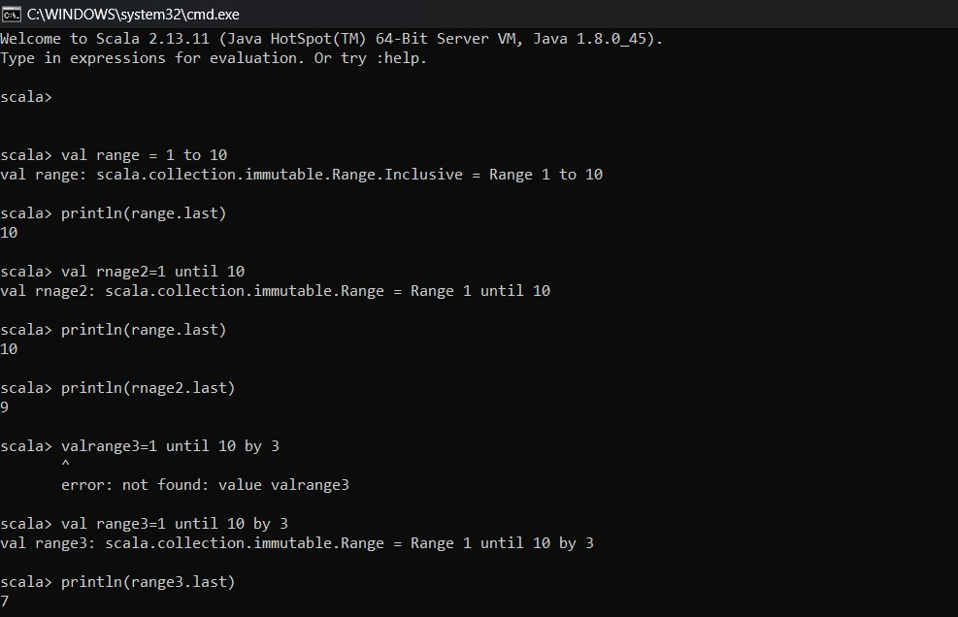

### TUPLE

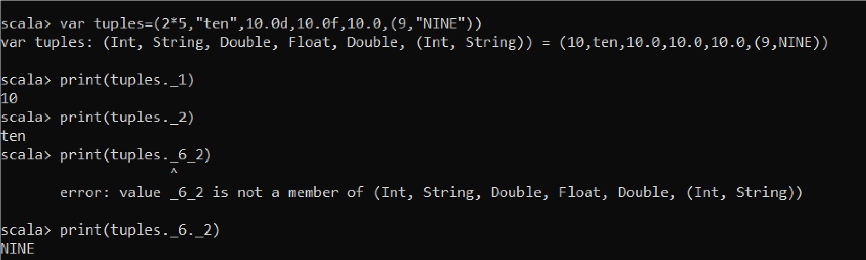

### LIST

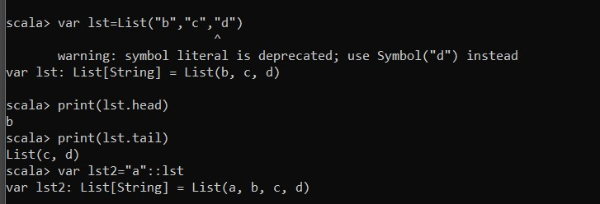

### ARRAY

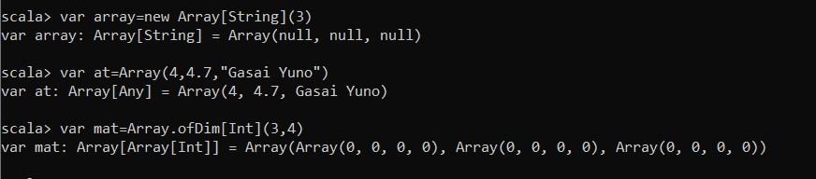

https://github.com/ALOKSINGH/SCALA/blob/main/6SEP23.pdf